EXPERIMENT - 2
Bus Ticket Booking System using the Figma Tool
Field | Details
Name | M.Ramprasadh
Register No. | 192511355
Course Code | CSA1007
Date | 26 October 2026
Tool Used | Figma (design and interactive prototype); Visual Studio Code and a web browser (local HTML version)

1. Aim

2. Objectives
- Understand the difference between a sketch, a wireframe and a prototype.
- Plan the screens and the user flow of a bus ticket booking app before designing.
- Create mobile frames in Figma and design four screens with a consistent colour palette, text styles and components.
- Link the screens with prototype interactions so that the booking flow can be clicked through.
- Present the prototype, publish or share it, and capture screenshots of every screen.
- Build the Home screen as an HTML/CSS/JavaScript page, run it on localhost and compare it with the Figma design.

3. Basic Concepts (in Simple Words)
Figma: A web-based design tool used to design the look of apps and websites and to link the screens into a clickable demo. It needs no installation and works in the browser.
Prototype: A simple, early model of an app. It looks and behaves like the real app (buttons can be clicked) but it has no real database or payment system behind it.
Frame: A container in Figma that acts like one phone screen. Each screen of the app is one frame.
Component: A reusable design element, such as a button or a bus card, that is drawn once and used many times.
Auto layout: A Figma feature that arranges the items inside a frame (spacing, padding, direction) automatically.
Interaction (Prototype link): A rule such as “when the user clicks Search buses, open the Available buses screen”.
User flow: The path a user follows to finish a task. Here: Home > Available buses > Choose seat > Booking confirmed.

4. Requirements
- A computer with an internet connection and a web browser (Google Chrome was used).
- A free Figma account (sign in at figma.com).
- Visual Studio Code and Python installed, for running the local HTML version (optional part).
- The project files: index.html, package.json, README.txt and run-localhost.bat (folder busly-localhost).
- Assumption: a single route (Boston to New York) with three sample buses is enough for the prototype. All fares and seats are sample data.

5. Design Plan

5.1 Screens and user flow
No. | Screen | Purpose | Main element
1 | Home | Enter origin, destination and date and start a search | Search card and Search buses button
2 | Available buses | Compare buses and pick a trip | Bus cards with Select seats button
3 | Choose your seat | Pick one or more seats on the bus layout | Seat map and Continue to book button
4 | Booking confirmed | Show the ticket summary | Ticket card and Done button

Flow: Home > Available buses > Choose your seat > Booking confirmed > Home (Done).

5.2 Design choices
Item | Value | Used for
Primary green | #086B55 | Header, selected seat, Select seats buttons
Accent yellow | #FFCC4D | Main action buttons (Search buses, Continue to book, Done)
Text colour | #202D2A | Headings and body text
Background | #F3F7F5 | Screen background
Frame size | iPhone frame (about 393 x 852) | All four screens
Font | Sans-serif (Inter / system) | Titles bold, labels small and grey

6. Step-by-Step Procedure

Part A: Set Up Figma and the Frames
- Open Figma. Open a browser, go to figma.com and sign in with your account. Click Create new (or the + button) and choose Design file to open a blank canvas.
- Name the file. Double-click the file title at the top and rename it Busly - Bus Ticket Booking Prototype.
- Create the first frame. Press F (Frame tool). In the right panel choose Phone > iPhone so that a mobile-sized frame appears. Rename it 1 Home (double-click the name in the Layers panel).
- Duplicate the frame. Select the frame and press Ctrl + D three times. Rename the copies 2 Available buses, 3 Choose seat and 4 Booking confirmed and place the four frames side by side.
- Save the colour styles. Select a shape, click the fill colour, and use the + in Styles to save #086B55 (Primary), #FFCC4D (Accent), #202D2A (Text) and #F3F7F5 (Background). Using styles keeps all screens consistent.

Part B: Design Screen 1 - Home
- Draw the header. Inside frame 1, draw a rectangle for the top area and fill it with the Primary green (a light gradient adds depth). Add the logo box (yellow rounded square) with the text Busly and a round profile icon on the right.
- Add the greeting. With the Text tool (T) type “Good morning, Alex” in small white text and the heading “Where are you going today?” in large bold white text.
- Build the search card. Draw a white rounded rectangle that overlaps the header. Inside it add two location rows (Leaving from: Boston and Going to: New York), a round swap button, a Departure row (Fri, 13 June with a Change link) and a yellow Search buses button. Select the items and press Shift + A to apply Auto layout so the spacing stays even.
- Add Recent searches. Add the heading “Recent searches” with a See all link and one white card: “Boston to New York - Fri, 13 June - 1 passenger”.
- Add the bottom navigation. At the bottom draw a white bar with three items: Home, My tickets and Profile, each with an icon and a label. Colour the active tab (Home) green. The finished screen is shown in Figure 1.
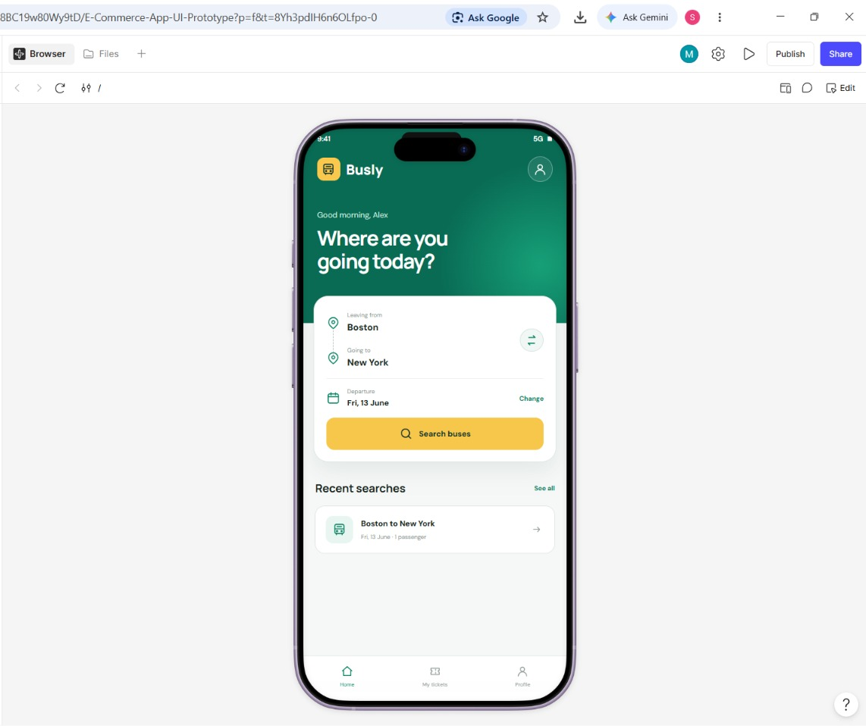
Figure 1: Screen 1 - Home screen of the Busly prototype in Figma

Part C: Design Screen 2 - Available Buses
- Add the top bar. In frame 2 add a back button and the title Boston → New York with the sub-text “Fri, 13 June · 1 passenger”.
- Add the date tabs. Add four tabs: Thu 12, Fri 13 (selected, green), Sat 14 and Sun 15.
- Create one bus card. Draw a white rounded card. Add the bus icon, the operator name (SwiftLine), the type (AC Sleeper) and the rating (★ 4.8); the departure and arrival times (07:30 and 13:45) with the duration (6h 15m); and at the bottom “12 seats left”, the fare ($24 /seat) and a green Select seats button.
- Turn the card into a component. Select the card and press Ctrl + Alt + K to create a component. Place two more instances and change only the text: Roadway (AC Seater, 09:15 - 15:55, 6h 40m, $19, 8 seats left) and Night Rider (Premium Sleeper, 22:00 - 04:50, 6h 50m, $29, 5 seats left). Add the heading “Available buses - 3 trips found” and a Filter button above the cards (Figure 2).
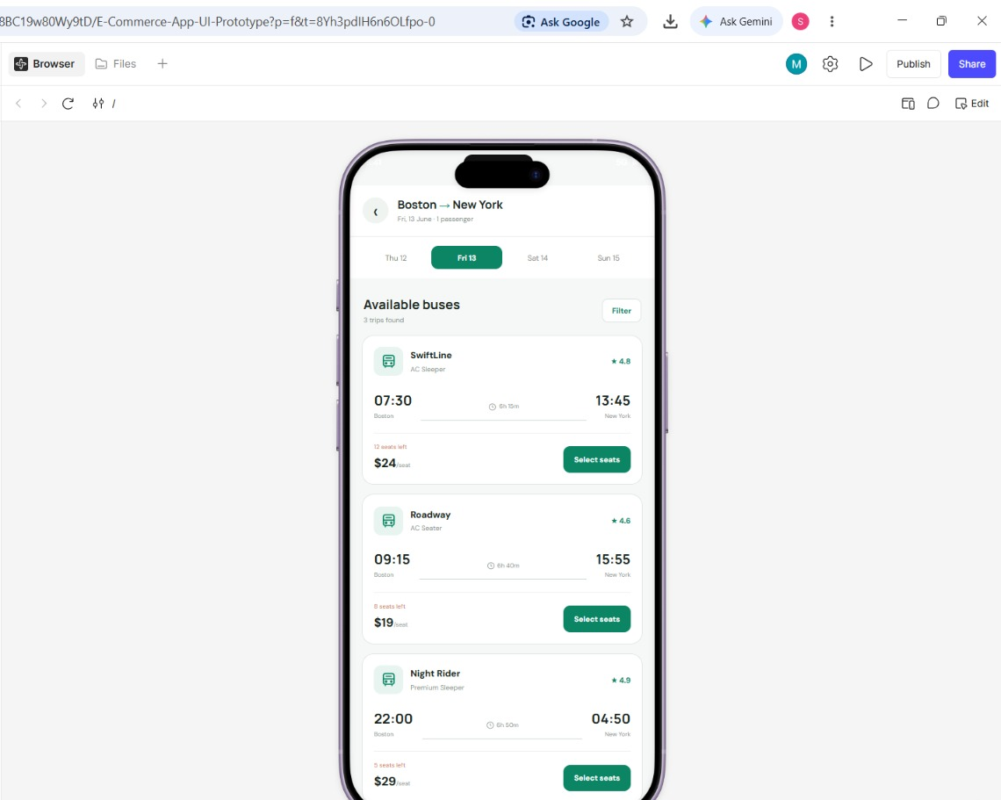
Figure 2: Screen 2 - Available buses list (3 trips found)

Part D: Design Screen 3 - Choose Your Seat
- Add the title bar. In frame 3 add a back button and the title Choose your seat with the sub-text “SwiftLine · 07:30”.
- Add the legend. Add three small squares with labels: Available (white), Selected (green) and Booked (grey).
- Draw the bus layout. Draw a tall rounded rectangle as the bus body with a steering-wheel circle at the top right. Create one seat as a small rounded square with a number and turn it into a component with three variants: Available, Selected and Booked. Place seats 1 to 20 in rows with a gap for the aisle, set seats 3, 7, 12 and 16 to Booked and seats 15 and 18 to Selected.
- Add the summary. Below the bus add “Selected seats: 15, 18” and “Total: $48” (2 seats x $24) and a yellow Continue to book → button (Figure 3).
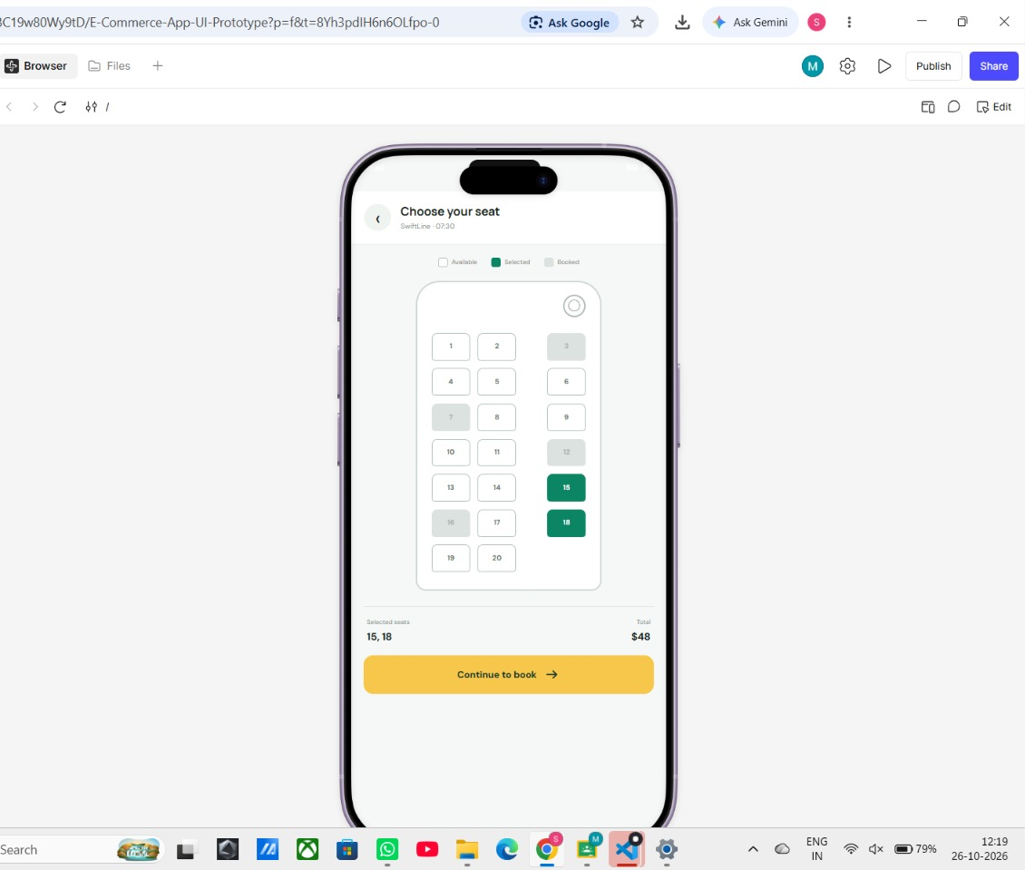
Figure 3: Screen 3 - Seat selection with available, selected and booked seats

Part E: Design Screen 4 - Booking Confirmed
- Add the success icon. In frame 4 fill the background with a very light green gradient. Draw a green circle with a ticket icon at the top centre.
- Add the message. Add the small green label BOOKING CONFIRMED, the large heading You’re all set! and the line “Your ticket from Boston to New York has been booked successfully.”
- Add the ticket card. Draw a white rounded card showing 07:30 ---- 13:45 with Boston and New York below, a dotted divider, and the three details Date, Seat, Total ($48).
- Add the Done button. Add a full-width yellow Done button under the card (Figure 4).
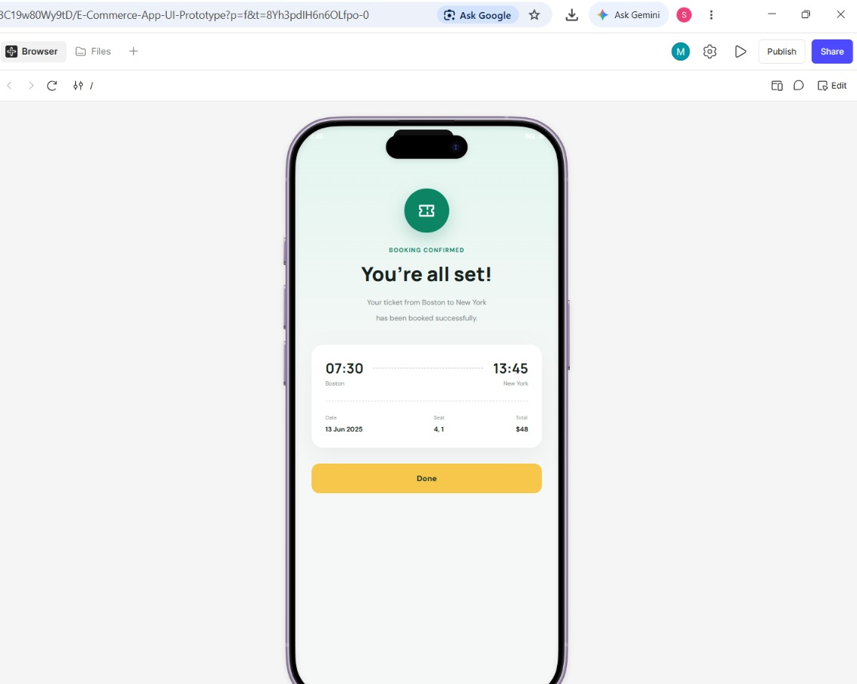
Figure 4: Screen 4 - Booking confirmed (ticket summary)

Part F: Link the Screens (Prototype)
- Open the Prototype tab. In the right panel click Prototype. Select an element and drag the small circle that appears on its edge to the target frame.
- Create the links. For each link set Trigger = On click, Action = Navigate to and Animation = Smart animate (or Move in), using Table 1.
Element | Trigger | Action | Destination
Search buses button (Screen 1) | On click | Navigate to | 2 Available buses
Select seats button (Screen 2) | On click | Navigate to | 3 Choose seat
Continue to book button (Screen 3) | On click | Navigate to | 4 Booking confirmed
Done button (Screen 4) | On click | Navigate to | 1 Home
Back button (Screens 2 and 3) | On click | Navigate back | Previous screen
Table 1: Prototype interactions used in the Busly flow
- Set the starting frame. Select frame 1 Home and mark it as the Starting point (flow start) in the Prototype panel.
- Test the prototype. Click the Play (▶) button at the top right. Click Search buses, Select seats, Continue to book and Done to check that the full flow works and returns to Home. Correct any wrong link.
- Publish and share. Click Publish or Share at the top right to get a link for the prototype, and set the access (view only) as required.

Part G: Build the Home Screen as a Local Web Page (VS Code)
To confirm that the design can be turned into working code, the Home screen and a simple search-results screen were also built as one HTML file with CSS and JavaScript.
- Create the project folder. Create a folder busly-localhost and open it in Visual Studio Code (File > Open Folder).
- Add the files. Create index.html (all the HTML, CSS and JavaScript), package.json (a start script), README.txt and run-localhost.bat. In index.html the colours from the Figma design are stored as CSS variables, for example --green: #086b55 and --yellow: #ffcc4d (Figure 5). The full code is given in Section 10.
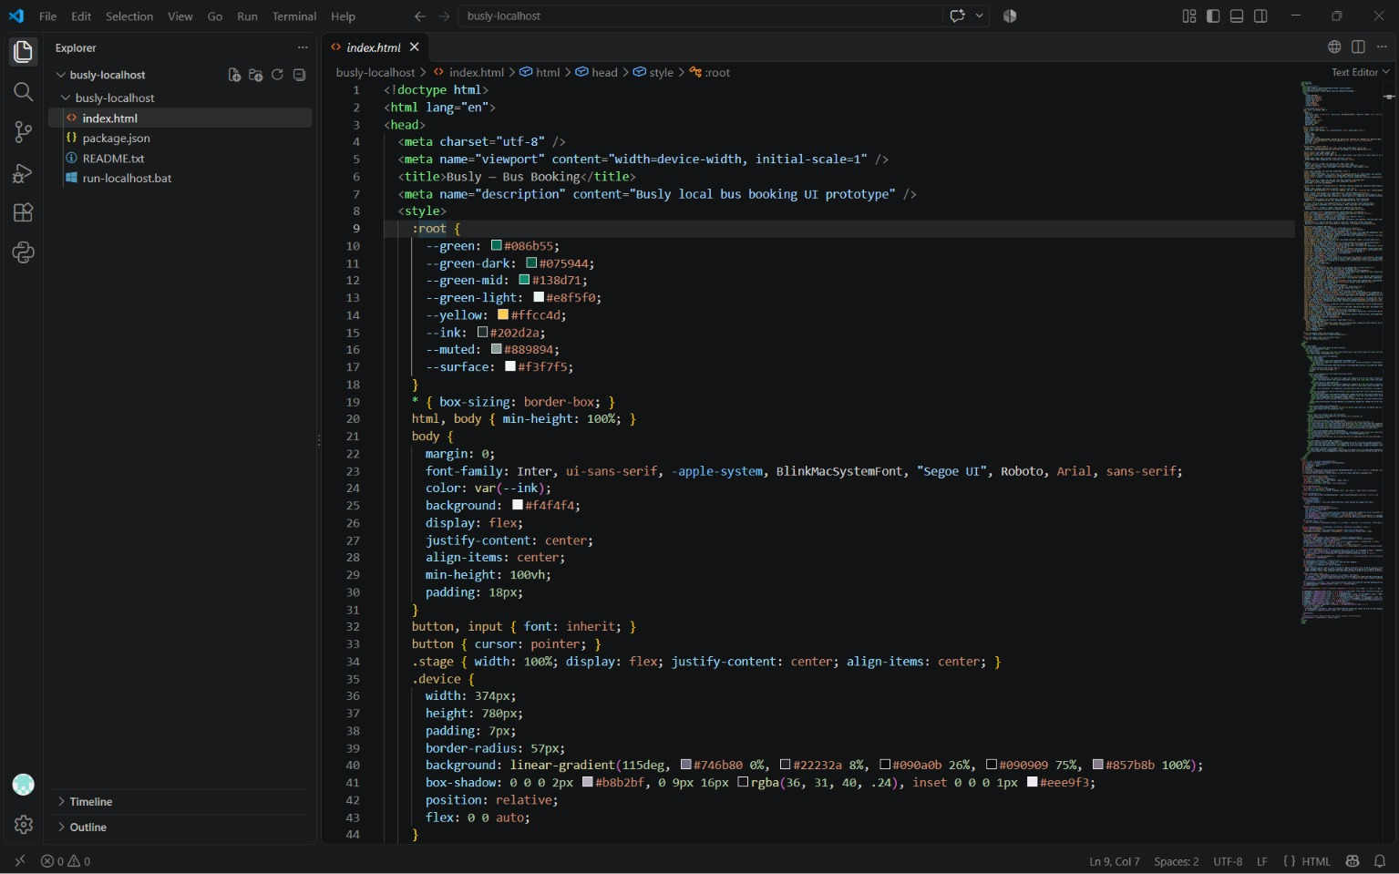
Figure 5: index.html in Visual Studio Code - colour variables defined at the top of the style section
- Start the local server. Open the Terminal in VS Code and run the command below. (Double-clicking run-localhost.bat does the same on Windows.)
python -m http.server 8000
- Preview the page. Open http://localhost:8000/ in the VS Code Simple Browser or in Chrome. The Busly home screen appears inside a phone frame (Figures 6 and 7).
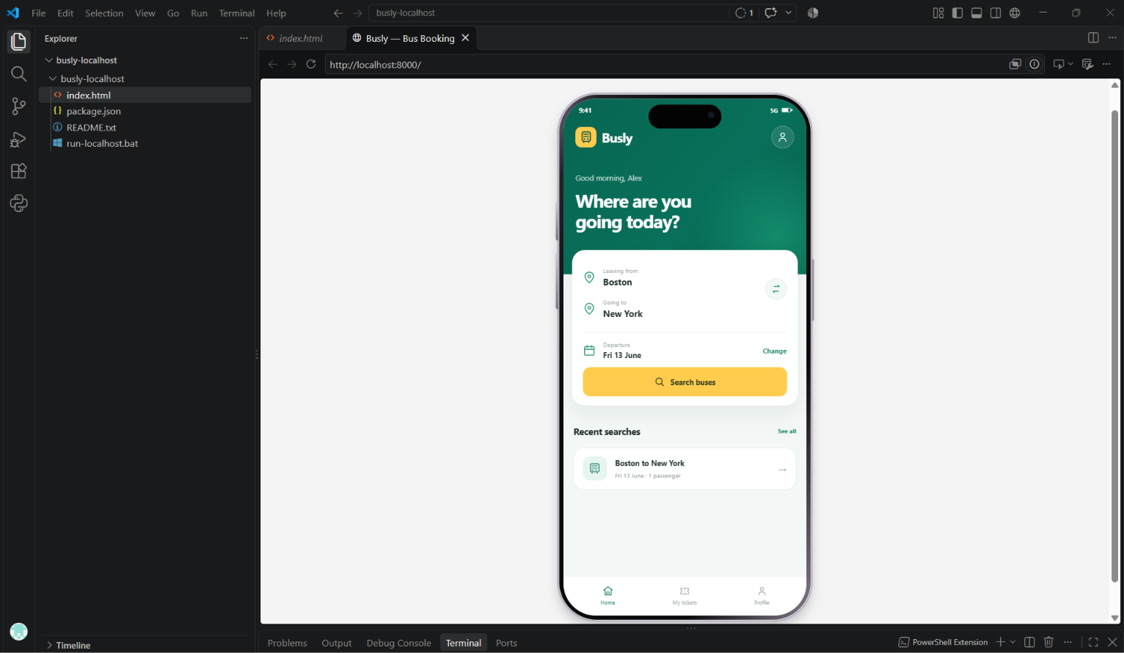
Figure 6: Busly page running at http://localhost:8000/ inside the VS Code preview, with the project files in the Explorer
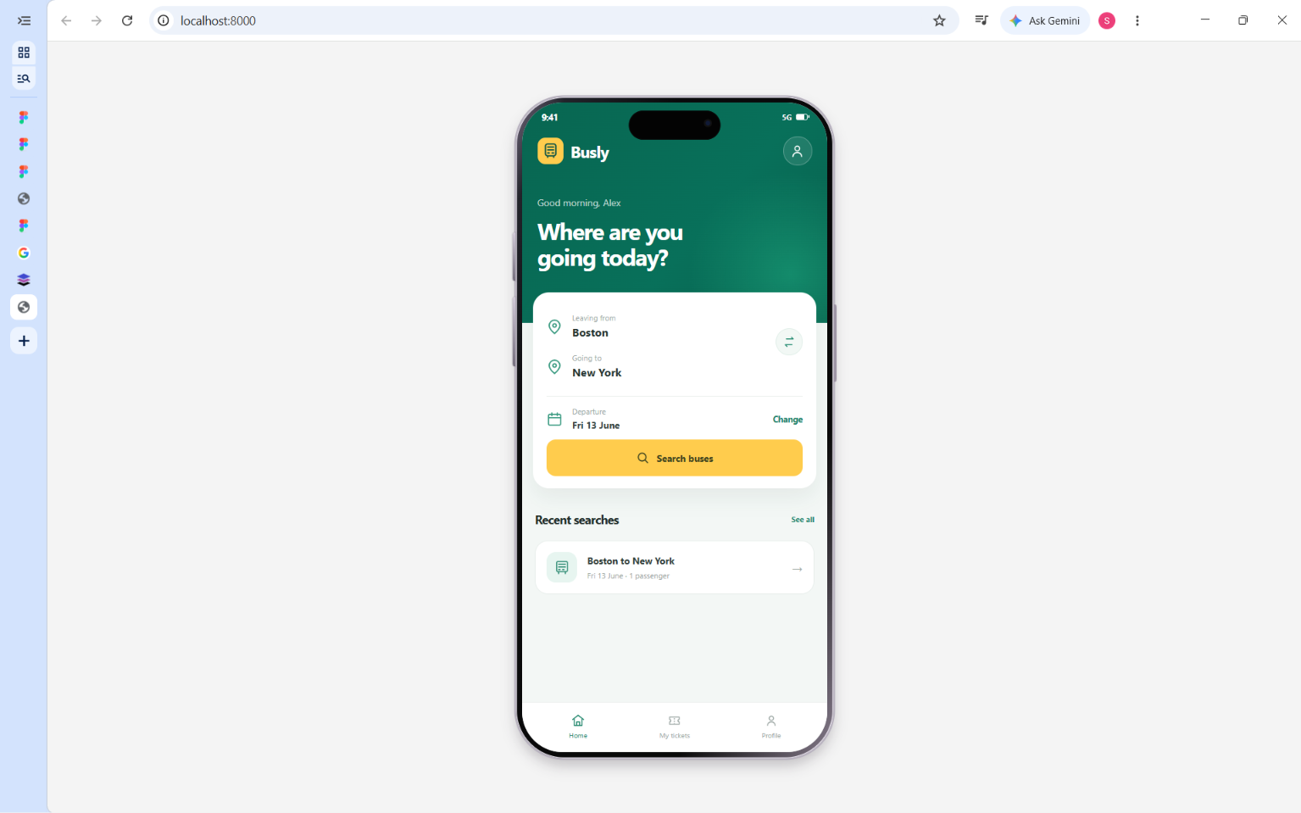
Figure 7: Busly home screen opened in the Chrome browser at localhost:8000
- Test the features. Click the swap button to exchange the two cities, click Change to pick another date, then click Search buses. The sample list of buses opens, the search is added to Recent searches, and the My tickets and Profile tabs can be opened from the bottom bar.

Part H: Capture the Output
- Take screenshots. Capture each Figma screen in the Play mode (Figures 1 to 4) and the VS Code and browser views (Figures 5 to 7), and paste them under the matching step in this record.

7. Observation
Sample bus data used in the prototype (Boston to New York, Fri 13 June)
Bus | Type | Departs | Arrives | Duration | Fare | Seats left
SwiftLine | AC Sleeper | 07:30 | 13:45 | 6h 15m | $24 | 12
Roadway | AC Seater | 09:15 | 15:55 | 6h 40m | $19 | 8
Night Rider | Premium Sleeper | 22:00 | 04:50 | 6h 50m | $29 | 5

Results of the flow test
No. | Action | Expected result | Status
1 | Click Search buses on Home | Available buses screen opens | Pass
2 | Click Select seats on a bus | Choose your seat screen opens | Pass
3 | Tap seats 15 and 18 | Seats turn green; total shows $48 | Pass
4 | Click Continue to book | Booking confirmed screen opens | Pass
5 | Click Done | Returns to the Home screen | Pass
6 | Swap, Change date, Search (local page) | Cities swap; date changes; sample buses are listed | Pass

The prototype has 4 screens and 5 clickable links, and the complete booking journey can be followed in the Play mode. Reusing components (bus card, seat) kept the screens consistent and saved time. The local HTML page reproduces the Home screen closely and adds working behaviour (swap, date change, recent searches), but its results list uses sample data only; the seat-selection and confirmation screens exist only in the Figma prototype.

8. Result
A simple, clickable prototype of the Busly bus ticket booking system was sketched in Figma with four linked screens: Home, Available buses, Choose your seat and Booking confirmed. The Home screen was also implemented as a local web page and run successfully at http://localhost:8000/ using Visual Studio Code and Python.

9. Conclusion
This experiment showed how Figma can be used to plan and test an app idea before any real programming is done. Frames, a fixed colour palette, reusable components and simple On-click links were enough to build a complete booking flow that can be presented and shared. Running the Home screen as HTML, CSS and JavaScript on localhost showed how the same design can later be developed into a working application, with real bus data, payment and ticket storage added in the next stages.

10. Source Code
The complete source code of the local Busly page is given below. The project folder busly-localhost contains index.html (HTML, CSS and JavaScript) and package.json. Run it with the command python -m http.server 8000 and open http://localhost:8000/.

10.1 package.json
{
"name": "busly-localhost-prototype",
"version": "1.0.0",
"private": true,
"description": "Standalone local recreation of the Busly mobile UI",
"scripts": { "start": "python -m http.server 8000" }
}

10.2 index.html
<!doctype html>
<html lang="en">
<head>
<meta charset="utf-8" />
<meta name="viewport" content="width=device-width, initial-scale=1" />
<title>Busly — Bus Booking</title>
<meta name="description" content="Busly local bus booking UI prototype" />
<style>
:root {
--green: #086b55;
--green-dark: #075944;
--green-mid: #138d71;
--green-light: #e8f5f0;
--yellow: #ffcc4d;
--ink: #202d2a;
--muted: #889894;
--surface: #f3f7f5;
}
* { box-sizing: border-box; }
html, body { min-height: 100%; }
body {
margin: 0;
font-family: Inter, ui-sans-serif, -apple-system, BlinkMacSystemFont, "Segoe UI", Roboto, Arial, sans-serif;
color: var(--ink);
background: #f4f4f4;
display: flex;
justify-content: center;
align-items: center;
min-height: 100vh;
padding: 18px;
}
button, input { font: inherit; }
button { cursor: pointer; }
.stage { width: 100%; display: flex; justify-content: center; align-items: center; }
.device {
width: 374px;
height: 780px;
padding: 7px;
border-radius: 57px;
background: linear-gradient(115deg, #746b80 0%, #22232a 8%, #090a0b 26%, #090909 75%, #857b8b 100%);
box-shadow: 0 0 0 2px #b8b2bf, 0 9px 16px rgba(36, 31, 40, .24), inset 0 0 0 1px #eee9f3;
position: relative;
flex: 0 0 auto;
}
.device::before, .device::after {
content: ""; position: absolute; left: -4px; width: 3px; border-radius: 3px 0 0 3px;
background: linear-gradient(#d1c9d7, #777180); box-shadow: 0 0 0 1px rgba(50,42,57,.12);
}
.device::before { top: 160px; height: 57px; }
.device::after { top: 236px; height: 82px; }
.side-button { position: absolute; right: -4px; top: 245px; height: 91px; width: 3px; border-radius: 0 3px 3px 0; background: #9e95a5; }
.screen {
height: 100%; width: 100%; overflow: hidden; position: relative;
border-radius: 48px; background: var(--surface); isolation: isolate;
}
.status {
position: absolute; z-index: 10; top: 8px; left: 20px; right: 20px;
height: 18px; display: flex; justify-content: space-between; align-items: center;
color: #fff; font-size: 10px; font-weight: 700; letter-spacing: -.2px; padding: 0 3px;
pointer-events: none;
}
.status-right { display: flex; gap: 5px; align-items: center; }
.signal { font-size: 9px; }
.battery { width: 14px; height: 7px; border: 1px solid rgba(255,255,255,.9); border-radius: 2px; position: relative; }
.battery::before { content:""; display:block; height:100%; width:72%; background:#fff; }
.battery::after { content:""; position:absolute; right:-3px; top:1px; height:3px; width:2px; background:#fff; border-radius:0 1px 1px 0; }
.island {
position: absolute; z-index: 12; top: 9px; left: 50%; transform: translateX(-50%);
width: 108px; height: 35px; border-radius: 22px; background: #030303;
box-shadow: inset 0 0 0 1px #080808;
}
.island::after { content:""; position:absolute; right:12px; top:12px; height:6px; width:6px; border-radius:50%; background:#101a36; box-shadow:0 0 0 2px #111; }
.hero {
height: 260px; padding: 40px 18px 0; position: relative; color: #fff;
background: radial-gradient(circle at 88% 78%, rgba(29, 170, 128, .54), transparent 32%), linear-gradient(130deg, #086651 0%, #08705a 58%, #08604d 100%);
}
.topbar { height: 34px; display:flex; align-items:center; justify-content:space-between; }
.brand { display:flex; gap:8px; align-items:center; font-size:19px; font-weight:750; letter-spacing:-.5px; }
.brand-mark { height:31px; width:31px; display:grid; place-items:center; background:var(--yellow); color:#145746; border-radius:9px; }
.profile-button {
display:grid; place-items:center; height:34px; width:34px; padding:0; border-radius:50%;
border:1px solid rgba(255,255,255,.25); background:rgba(255,255,255,.10); color:#fff;
}
.greeting { font-size:11px; color:rgba(255,255,255,.72); margin-top:36px; letter-spacing:.05px; }
h1 { font-size:27px; line-height:1.13; letter-spacing:-1.05px; margin:9px 0 0; font-weight:760; }
.booking-card {
position: relative; z-index: 2; margin: -36px 13px 0; padding: 17px 16px 14px;
background:#fff; border-radius:19px; box-shadow:0 11px 24px rgba(18,56,44,.065);
}
.places { position:relative; padding-bottom:11px; border-bottom:1px solid #edf0ee; }
.place-row { display:flex; align-items:center; min-height:47px; gap:11px; position:relative; }
.place-icon { color:#399a80; flex:0 0 auto; display:flex; }
.place-field { min-width:0; display:flex; flex-direction:column; gap:3px; flex:1; }
.field-label { color:#a0aaa7; font-size:9px; line-height:1; }
.city-input { padding:0; border:0; outline:0; width:100%; min-width:0; color:#263531; font-size:13px; font-weight:700; background:transparent; }
.swap-button {
position:absolute; right:0; top:25px; z-index:2; width:32px; height:32px; border-radius:50%;
display:grid; place-items:center; color:#258c72; border:1px solid #e0eee8; background:#f2f8f5;
}
.destination-row { padding-right:45px; }
.date-row { padding:12px 0 10px; display:flex; align-items:center; gap:11px; }
.date-content { min-width:0; flex:1; display:flex; flex-direction:column; gap:4px; }
.date-value { color:#35433f; font-size:11px; font-weight:650; }
.change-date { border:0; background:none; color:#21846c; font-size:10px; font-weight:700; padding:8px 0 8px 8px; }
.real-date { position:absolute; width:1px; height:1px; opacity:0; pointer-events:none; }
.search-button { width:100%; height:43px; border:0; border-radius:11px; background:var(--yellow); color:#3e441e; font-size:11px; font-weight:750; display:flex; align-items:center; justify-content:center; gap:8px; transition:filter .16s, transform .16s; }
.search-button:hover { filter:brightness(.98); }
.search-button:active { transform:scale(.99); }
.below { padding: 26px 15px 79px; overflow-y:auto; max-height:calc(100% - 260px); scrollbar-width:none; }
.below::-webkit-scrollbar { display:none; }
.section-heading { display:flex; align-items:center; justify-content:space-between; margin-bottom:14px; }
.section-heading h2 { margin:0; font-size:14px; letter-spacing:-.35px; font-weight:750; }
.text-link { border:0; background:none; color:#22886e; font-size:9px; font-weight:700; padding:5px 0 5px 8px; }
.recent-list { display:flex; flex-direction:column; gap:8px; }
.recent-card { min-height:63px; width:100%; border:1px solid #e8eeeb; background:#fff; border-radius:15px; display:flex; align-items:center; text-align:left; padding:10px 13px; gap:12px; color:inherit; }
.recent-icon { width:36px; height:36px; flex:0 0 36px; display:grid; place-items:center; color:#338e77; border-radius:11px; background:#e7f5f0; }
.recent-main { min-width:0; flex:1; display:flex; flex-direction:column; gap:5px; }
.recent-title { color:#2f3c38; font-size:11px; font-weight:750; }
.recent-sub { color:#9aa5a1; font-size:9px; }
.recent-arrow { color:#a0aaa7; flex:0 0 auto; }
.empty-state { padding:17px 12px; border-radius:14px; border:1px dashed #d9e5df; color:#84928d; text-align:center; font-size:11px; background:rgba(255,255,255,.65); }
.tabbar { position:absolute; z-index:5; bottom:0; left:0; right:0; height:59px; display:flex; justify-content:space-around; align-items:center; background:rgba(255,255,255,.97); border-top:1px solid #edf0ee; padding:4px 9px 5px; }
.tab { width:33.333%; height:47px; padding:2px 0; display:flex; flex-direction:column; justify-content:center; align-items:center; gap:3px; border:0; background:transparent; color:#a0aaa7; font-size:8px; }
.tab.active { color:#278a70; }
.tab svg { width:17px; height:17px; }
.view { display:none; }
.view.active { display:block; }
.secondary-view { padding:31px 15px 88px; overflow:auto; max-height:100%; scrollbar-width:none; }
.secondary-view h2 { margin:0 0 6px; font-size:21px; letter-spacing:-.6px; }
.secondary-view .lead { margin:0 0 22px; font-size:11px; line-height:1.5; color:#899691; }
.info-card { background:#fff; border:1px solid #e8eeeb; border-radius:16px; padding:17px 15px; margin:12px 0; }
.info-title { font-size:12px; font-weight:750; margin-bottom:8px; }
.info-copy { font-size:10px; color:#8b9792; line-height:1.5; }
.result-toolbar { display:flex; align-items:center; justify-content:space-between; gap:8px; margin-bottom:16px; }
.back-button { border:1px solid #deebe5; background:#fff; color:#287e69; border-radius:10px; padding:8px 10px; font-size:10px; font-weight:700; }
.results-date { font-size:10px; color:#8a9691; }
.bus-result { background:white; border:1px solid #e8eeeb; border-radius:15px; padding:14px; margin-bottom:10px; }
.bus-result-top { display:flex; justify-content:space-between; gap:8px; align-items:flex-start; }
.bus-name { font-size:12px; font-weight:750; }
.bus-type { color:#9aa5a1; font-size:9px; margin-top:4px; }
.bus-price { font-size:14px; font-weight:800; color:#16775f; white-space:nowrap; }
.bus-timing { display:flex; align-items:center; gap:8px; margin:16px 0 12px; }
.time-block strong { display:block; font-size:13px; }
.time-block small { display:block; color:#8c9793; font-size:9px; margin-top:3px; }
.journey-line { border-top:1px dashed #cfded7; flex:1; position:relative; text-align:center; height:1px; }
.journey-line span { position:relative; top:-8px; display:inline-block; background:#fff; padding:0 5px; font-size:8px; color:#9aa5a1; }
.seat-row { display:flex; justify-content:space-between; align-items:center; gap:8px; border-top:1px solid #edf1ee; padding-top:11px; }
.seat-left { color:#71817a; font-size:9px; }
.select-bus { border:0; border-radius:8px; background:var(--yellow); color:#3e441e; font-weight:750; font-size:10px; padding:9px 12px; }
.notice { margin-top:10px; padding:11px 12px; border-radius:11px; background:#f0f8f4; color:#4c7c6c; font-size:9px; line-height:1.4; }
.toast { position:absolute; z-index:20; bottom:70px; left:50%; transform:translateX(-50%); width:max-content; max-width:85%; padding:10px 13px; background:#203a32; color:#fff; font-size:10px; border-radius:12px; box-shadow:0 5px 18px #0002; display:none; }
.toast.show { display:block; }
.modal-backdrop { position:absolute; z-index:30; inset:0; display:none; align-items:flex-end; background:rgba(0,0,0,.28); }
.modal-backdrop.open { display:flex; }
.sheet { background:#fff; border-radius:22px 22px 0 0; width:100%; padding:23px 20px 28px; box-shadow:0 -6px 30px #0001; }
.sheet h3 { margin:0 0 7px; font-size:17px; }
.sheet p { margin:0 0 17px; color:#899691; font-size:11px; line-height:1.5; }
.sheet-field { width:100%; border:1px solid #dce7e1; border-radius:10px; padding:12px; outline-color:#23896d; font-size:12px; }
.sheet-actions { display:flex; gap:8px; margin-top:14px; }
.sheet-actions button { flex:1; border-radius:10px; padding:12px; border:0; font-size:11px; font-weight:750; }
.cancel { background:#f0f5f2; color:#527568; }
.apply { background:var(--yellow); color:#41451f; }
@media (max-width: 430px) {
body { padding:0; background:var(--surface); align-items:stretch; }
.stage { min-height:100svh; }
.device { width:100%; max-width:430px; height:100svh; min-height:650px; padding:0; border-radius:0; box-shadow:none; background:var(--surface); }
.device::before, .device::after, .side-button { display:none; }
.screen { border-radius:0; }
.island { top:9px; }
.hero { padding-top:40px; }
.status { top:8px; }
}
@media (max-height: 810px) and (min-width: 431px) {
.device { transform:scale(.92); transform-origin:center; }
}
@media (max-height: 720px) and (min-width: 431px) {
.device { transform:scale(.82); }
}
</style>
</head>
<body>
<main class="stage">
<div class="device" aria-label="Busly app device preview">
<span class="side-button"></span>
<div class="screen">
<div class="status"><span>9:41</span><span class="status-right"><span class="signal">5G</span><span class="battery"></span></span></div>
<div class="island" aria-hidden="true"></div>

<section class="view active" id="homeView">
<header class="hero">
<div class="topbar">
<div class="brand"><span class="brand-mark" aria-hidden="true">
<svg width="21" height="21" viewBox="0 0 24 24" fill="none" stroke="currentColor" stroke-width="1.8" stroke-linecap="round" stroke-linejoin="round"><rect x="5" y="3" width="14" height="16" rx="3"/><path d="M8 7h8M8 11h8M8 15h2m4 0h2M8 19v2m8-2v2"/></svg>
</span>Busly</div>
<button class="profile-button" data-tab="profile" aria-label="Open profile"><svg width="19" height="19" viewBox="0 0 24 24" fill="none" stroke="currentColor" stroke-width="1.6" stroke-linecap="round"><circle cx="12" cy="8" r="3.5"/><path d="M5.5 20c.5-4 2.7-6 6.5-6s6 2 6.5 6"/></svg></button>
</div>
<p class="greeting">Good morning, Alex</p>
<h1>Where are you<br>going today?</h1>
</header>

<section class="booking-card" aria-label="Search bus journey">
<div class="places">
<div class="place-row">
<span class="place-icon"><svg width="19" height="19" viewBox="0 0 24 24" fill="none" stroke="currentColor" stroke-width="1.9" stroke-linecap="round" stroke-linejoin="round"><path d="M20 10c0 5-8 12-8 12S4 15 4 10a8 8 0 1 1 16 0Z"/><circle cx="12" cy="10" r="2.5"/></svg></span>
<label class="place-field"><span class="field-label">Leaving from</span><input class="city-input" id="origin" value="Boston" aria-label="Leaving from" list="cityOptions"></label>
</div>
<div class="place-row destination-row">
<span class="place-icon"><svg width="19" height="19" viewBox="0 0 24 24" fill="none" stroke="currentColor" stroke-width="1.9" stroke-linecap="round" stroke-linejoin="round"><path d="M20 10c0 5-8 12-8 12S4 15 4 10a8 8 0 1 1 16 0Z"/><circle cx="12" cy="10" r="2.5"/></svg></span>
<label class="place-field"><span class="field-label">Going to</span><input class="city-input" id="destination" value="New York" aria-label="Going to" list="cityOptions"></label>
</div>
<button class="swap-button" id="swapButton" aria-label="Swap origin and destination"><svg width="16" height="16" viewBox="0 0 24 24" fill="none" stroke="currentColor" stroke-width="1.8" stroke-linecap="round" stroke-linejoin="round"><path d="M7 7h12l-3-3M17 17H5l3 3"/></svg></button>
</div>
<datalist id="cityOptions"><option value="Boston"><option value="New York"><option value="Philadelphia"><option value="Washington, DC"><option value="Albany"><option value="Chicago"><option value="Los Angeles"><option value="San Francisco"><option value="Chennai"><option value="Bengaluru"><option value="Coimbatore"><option value="Madurai"></datalist>
<div class="date-row">
<span class="place-icon"><svg width="19" height="19" viewBox="0 0 24 24" fill="none" stroke="currentColor" stroke-width="1.8" stroke-linecap="round" stroke-linejoin="round"><rect x="3" y="5" width="18" height="16" rx="2"/><path d="M16 3v4M8 3v4M3 10h18"/></svg></span>
<div class="date-content"><span class="field-label">Departure</span><span class="date-value" id="dateLabel">Fri, 13 June</span></div>
<button class="change-date" id="changeDate">Change</button>
<input type="date" class="real-date" id="journeyDate" value="2025-06-13" aria-label="Departure date">
</div>
<button class="search-button" id="searchButton"><svg width="16" height="16" viewBox="0 0 24 24" fill="none" stroke="currentColor" stroke-width="2" stroke-linecap="round"><circle cx="10.8" cy="10.8" r="6.8"/><path d="m16 16 4.5 4.5"/></svg>Search buses</button>
</section>

<section class="below" id="recentSection">
<div class="section-heading"><h2>Recent searches</h2><button class="text-link" id="seeAll">See all</button></div>
<div class="recent-list" id="recentList"></div>
</section>
</section>

<section class="view secondary-view" id="ticketsView">
<h2>My tickets</h2><p class="lead">Your next journey, all in one place.</p>
<div id="ticketContent"></div>
</section>
<section class="view secondary-view" id="profileView">
<h2>Your profile</h2><p class="lead">Manage your Busly account and travel preferences.</p>
<div class="info-card"><div class="info-title">Alex Morgan</div><div class="info-copy">alex.morgan@example.com</div></div>
<div class="info-card"><div class="info-title">Passenger details</div><div class="info-copy">Update your name and contact details for a faster booking experience.</div></div>
<div class="info-card"><div class="info-title">Help & support</div><div class="info-copy">Need help with a trip? View booking help and frequently asked questions.</div></div>
<button class="search-button" id="homeFromProfile" style="margin-top:17px">Back to home</button>
</section>
<section class="view secondary-view" id="resultsView">
<div class="result-toolbar"><button class="back-button" id="backHome">← Back</button><span class="results-date" id="resultsDate"></span></div>
<h2 id="resultsTitle">Available buses</h2><p class="lead" id="resultsSubtitle"></p>
<div id="resultsList"></div>
<div class="notice">Demo interface: bus listings and fares are sample data for this local prototype, not live availability.</div>
</section>

<nav class="tabbar" aria-label="Main navigation">
<button class="tab active" data-tab="home"><svg viewBox="0 0 24 24" fill="none" stroke="currentColor" stroke-width="1.7" stroke-linecap="round" stroke-linejoin="round"><path d="m3 10 9-7 9 7"/><path d="M5.5 9v11h13V9M9.5 20v-6h5v6"/></svg><span>Home</span></button>
<button class="tab" data-tab="tickets"><svg viewBox="0 0 24 24" fill="none" stroke="currentColor" stroke-width="1.7" stroke-linejoin="round"><path d="M4 6h16v4a2 2 0 0 0 0 4v4H4v-4a2 2 0 0 0 0-4Z"/><path d="M12 8v2m0 2v2m0 2v1"/></svg><span>My tickets</span></button>
<button class="tab" data-tab="profile"><svg viewBox="0 0 24 24" fill="none" stroke="currentColor" stroke-width="1.7" stroke-linecap="round"><circle cx="12" cy="8" r="3.5"/><path d="M5.5 20c.5-4 2.7-6 6.5-6s6 2 6.5 6"/></svg><span>Profile</span></button>
</nav>
<div class="toast" id="toast" role="status"></div>
<div class="modal-backdrop" id="dateModal" role="dialog" aria-modal="true" aria-labelledby="dateModalTitle">
<div class="sheet"><h3 id="dateModalTitle">Choose departure date</h3><p>Select the day you plan to travel.</p><input type="date" class="sheet-field" id="dateSheetInput" value="2025-06-13"><div class="sheet-actions"><button class="cancel" id="cancelDate">Cancel</button><button class="apply" id="applyDate">Apply date</button></div></div>
</div>
</div>
</div>
</main>
<script>
(() => {
const $ = (id) => document.getElementById(id);
const origin = $('origin'), destination = $('destination');
const recentList = $('recentList');
let currentView = 'home';
let toastTimer;
let searches = [];
try { searches = JSON.parse(localStorage.getItem('buslyRecentSearches') || '[]'); } catch (_) { searches = []; }
if (!Array.isArray(searches)) searches = [];
if (!searches.length) searches = [{from:'Boston',to:'New York',date:'2025-06-13',passengers:1}];

function formatDate(value, withYear = false) {
if (!value) return 'Choose a date';
const date = new Date(value + 'T12:00:00');
const opts = { weekday:'short', day:'numeric', month:'long' };
if (withYear) opts.year = 'numeric';
return new Intl.DateTimeFormat('en-US', opts).format(date);
}
function dateText(value) {
if (!value) return 'Fri, 13 June';
const date = new Date(value + 'T12:00:00');
return new Intl.DateTimeFormat('en-GB', {weekday:'short', day:'numeric', month:'long'}).format(date);
}
function saveSearches() {
try { localStorage.setItem('buslyRecentSearches', JSON.stringify(searches.slice(0,6))); } catch (_) {}
}
function renderRecent() {
recentList.innerHTML = '';
if (!searches.length) {
recentList.innerHTML = '<div class="empty-state">Your recent searches will appear here.</div>';
return;
}
searches.slice(0,4).forEach((trip) => {
const card = document.createElement('button');
card.className = 'recent-card';
card.type = 'button';
card.innerHTML = '<span class="recent-icon"><svg width="19" height="19" viewBox="0 0 24 24" fill="none" stroke="currentColor" stroke-width="1.7" stroke-linecap="round" stroke-linejoin="round"><rect x="4" y="3" width="16" height="15" rx="2"/><path d="M7 7h10M7 11h10M7 15h2m4 0h2M7 18v3m10-3v3"/></svg></span><span class="recent-main"><span class="recent-title"></span><span class="recent-sub"></span></span><span class="recent-arrow">→</span>';
card.querySelector('.recent-title').textContent = `${trip.from} to ${trip.to}`;
card.querySelector('.recent-sub').textContent = `${dateText(trip.date)} · ${trip.passengers || 1} passenger${(trip.passengers || 1) > 1 ? 's' : ''}`;
card.addEventListener('click', () => { origin.value = trip.from; destination.value = trip.to; $('journeyDate').value = trip.date || '2025-06-13'; updateDateLabel(); runSearch(false); });
recentList.appendChild(card);
});
if (searches.length > 4) {
const all = document.createElement('button'); all.className = 'text-link'; all.textContent = 'Show fewer'; all.style.alignSelf = 'flex-end'; all.addEventListener('click', () => { searches = searches.slice(0,1); saveSearches(); renderRecent(); }); recentList.appendChild(all);
}
}
function updateDateLabel() { $('dateLabel').textContent = dateText($('journeyDate').value); }
function showToast(message) {
const toast = $('toast'); toast.textContent = message; toast.classList.add('show');
clearTimeout(toastTimer); toastTimer = setTimeout(() => toast.classList.remove('show'), 2300);
}
function setView(view) {
currentView = view;
document.querySelectorAll('.view').forEach(el => el.classList.remove('active'));
const map = {home:'homeView',tickets:'ticketsView',profile:'profileView',results:'resultsView'};
$(map[view] || 'homeView').classList.add('active');
document.querySelectorAll('.tab').forEach(el => el.classList.toggle('active', el.dataset.tab === view));
$('recentSection').style.display = view === 'home' ? '' : 'none';
// Home has its own content flow; other screens have a full-height scroll area.
document.querySelectorAll('.secondary-view').forEach(el => el.style.display = el.classList.contains('active') ? 'block' : 'none');
}
function runSearch(addRecent = true) {
const from = origin.value.trim(), to = destination.value.trim(), date = $('journeyDate').value || '2025-06-13';
if (!from || !to) { showToast('Enter both departure and destination cities.'); return; }
if (from.toLowerCase() === to.toLowerCase()) { showToast('Choose two different cities.'); return; }
if (addRecent) {
searches = [{from,to,date,passengers:1}, ...searches.filter(s => !(s.from.toLowerCase() === from.toLowerCase() && s.to.toLowerCase() === to.toLowerCase() && s.date === date))].slice(0,6);
saveSearches(); renderRecent();
}
$('resultsTitle').textContent = `${from} to ${to}`;
$('resultsSubtitle').textContent = 'Choose a bus that fits your schedule.';
$('resultsDate').textContent = dateText(date);
const results = $('resultsList'); results.innerHTML = '';
const routes = [
{name:'GreenLine Express',type:'AC coach · Free Wi-Fi',depart:'08:30 AM',arrive:'12:45 PM',duration:'4h 15m',price:24, seats:12},
{name:'CityRide Premium',type:'Premium AC · Recliner seats',depart:'10:15 AM',arrive:'02:40 PM',duration:'4h 25m',price:31, seats:7},
{name:'NorthStar Travels',type:'Standard coach · USB charging',depart:'01:00 PM',arrive:'05:35 PM',duration:'4h 35m',price:19, seats:18}
];
routes.forEach((bus, index) => {
const el = document.createElement('article'); el.className = 'bus-result';
el.innerHTML = `<div class="bus-result-top"><div><div class="bus-name">${bus.name}</div><div class="bus-type">${bus.type}</div></div><div class="bus-price">$${bus.price}</div></div><div class="bus-timing"><div class="time-block"><strong>${bus.depart}</strong><small>${escapeHtml(from)}</small></div><div class="journey-line"><span>${bus.duration}</span></div><div class="time-block" style="text-align:right"><strong>${bus.arrive}</strong><small>${escapeHtml(to)}</small></div></div><div class="seat-row"><span class="seat-left">${bus.seats} seats left</span><button class="select-bus" data-bus="${index}">Select bus</button></div>`;
el.querySelector('.select-bus').addEventListener('click', () => showToast(`${bus.name} selected — demo booking only.`));
results.appendChild(el);
});
$('ticketContent').innerHTML = '<div class="info-card"><div class="info-title">No confirmed bookings yet</div><div class="info-copy">When you select and confirm a bus, your trip will be shown here. This prototype does not process payments.</div><button class="back-button" id="findBusFromTickets" style="margin-top:14px">Find a bus</button></div>';
$('findBusFromTickets').addEventListener('click', () => setView('home'));
setView('results');
}
function escapeHtml(text) { return String(text).replace(/[&<>"']/g, ch => ({'&':'&amp;','<':'&lt;','>':'&gt;','"':'&quot;',"'":'&#39;'}[ch])); }

$('swapButton').addEventListener('click', () => { const a = origin.value; origin.value = destination.value; destination.value = a; });
$('searchButton').addEventListener('click', () => runSearch(true));
$('changeDate').addEventListener('click', () => { $('dateSheetInput').value = $('journeyDate').value || '2025-06-13'; $('dateModal').classList.add('open'); });
$('cancelDate').addEventListener('click', () => $('dateModal').classList.remove('open'));
$('applyDate').addEventListener('click', () => { if ($('dateSheetInput').value) { $('journeyDate').value = $('dateSheetInput').value; updateDateLabel(); } $('dateModal').classList.remove('open'); });
$('dateModal').addEventListener('click', (e) => { if (e.target === $('dateModal')) $('dateModal').classList.remove('open'); });
$('seeAll').addEventListener('click', () => { if (searches.length > 1) { $('recentSection').querySelector('h2').textContent = 'Recent searches'; recentList.innerHTML = ''; searches.forEach(trip => { const card = document.createElement('button'); card.className='recent-card'; card.innerHTML='<span class="recent-icon">↔</span><span class="recent-main"><span class="recent-title"></span><span class="recent-sub"></span></span><span class="recent-arrow">→</span>'; card.querySelector('.recent-title').textContent=`${trip.from} to ${trip.to}`; card.querySelector('.recent-sub').textContent=dateText(trip.date)+' · 1 passenger'; card.addEventListener('click',()=>{origin.value=trip.from;destination.value=trip.to;$('journeyDate').value=trip.date;updateDateLabel();runSearch(false);}); recentList.appendChild(card); }); } else { showToast('Search for a trip to build your recent searches.'); } });
$('backHome').addEventListener('click', () => setView('home'));
$('homeFromProfile').addEventListener('click', () => setView('home'));
document.querySelectorAll('[data-tab]').forEach(el => el.addEventListener('click', () => {
const tab = el.dataset.tab;
if (tab === 'tickets') {
$('ticketContent').innerHTML = '<div class="empty-state">No tickets yet. Search for a bus to start planning your trip.</div><button class="search-button" id="ticketSearch" style="margin-top:16px">Search buses</button>';
$('ticketSearch').addEventListener('click', () => setView('home'));
}
setView(tab);
}));
// Keep the prototype's default booking card visually identical to the reference.
updateDateLabel(); renderRecent(); setView('home');
})();
</script>
</body>
</html>

